# Dropping Views in SQL

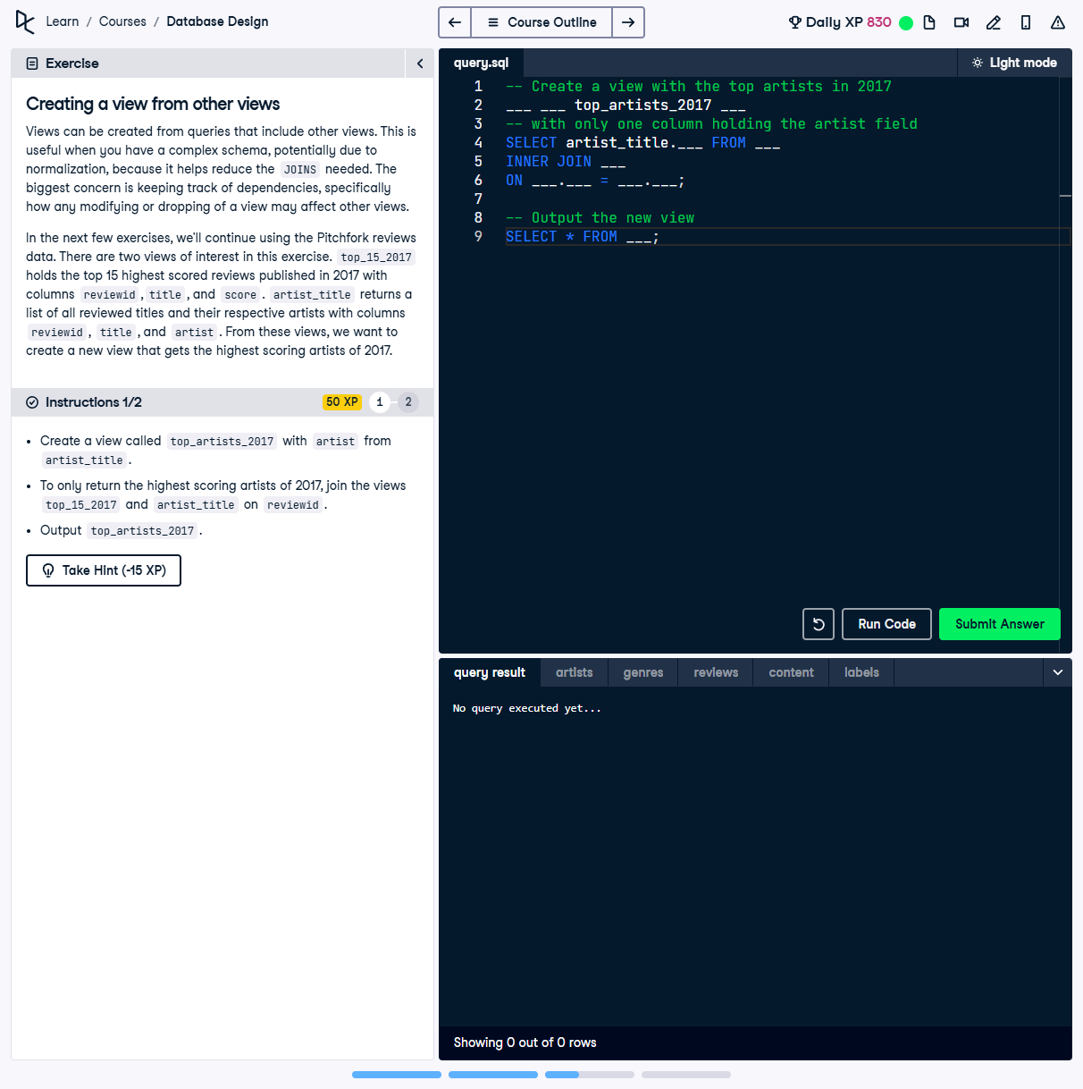

## Question:

Which is the DROP command that would drop both top_15_2017 and top_artists_2017?

## Possible Answers:

1. DROP VIEW top_15_2017 CASCADE;

2. DROP VIEW top_15_2017 RESTRICT;

3. DROP VIEW top_artists_2017 RESTRICT;

4. DROP VIEW top_artists_2017 CASCADE;

## Correct Answer:

DROP VIEW top_15_2017 CASCADE;

## Explanation of the Answer:

The correct answer is `DROP VIEW top_15_2017 CASCADE;` because the `CASCADE` option ensures that dependent views, such as `top_artists_2017`, are also dropped. The `RESTRICT` option would prevent the drop if dependencies exist, which means `top_artists_2017` would not be removed.